**IBM back-end development**

# **Software engineering**

* Application of scientific principles to the design and creation of software.
* Responsibilities of a software engineer:
  + designing, building, maintaining software systems.
  + Writing and testing software
  + Consulting with stakeholders, 3rd vendors,...

# **SDLC: software development life cycle**

## defined:

* 1. System of process to develop high-quality software
  2. Aim to produce software that meets requirements
  3. Defined phases with their own processes and deliverables
  4. Cycle of planning, design and development
  5. Minimise development risks and costs.

## Phases:

* 1. In many ver of SDLC organisations, name for each step can be different and some ver have more or less stages.
  2. Planning ⇒ design ⇒ development ⇒ testing ⇒ deployment ⇒ maintenance.

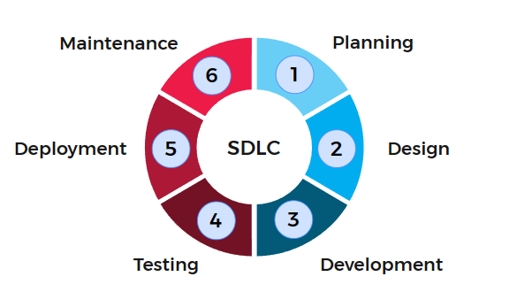

* 1. Planning:

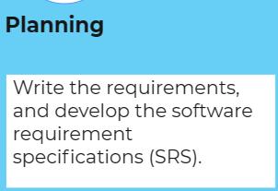

* + - Gathered, analysed, documented, prioritised.
    - Factors must be considered:
      * User, purpose, inputs/outputs, resourcing, risk, scheduling, compliance,...
      * Budgets, time, pj teams are identified.
    - 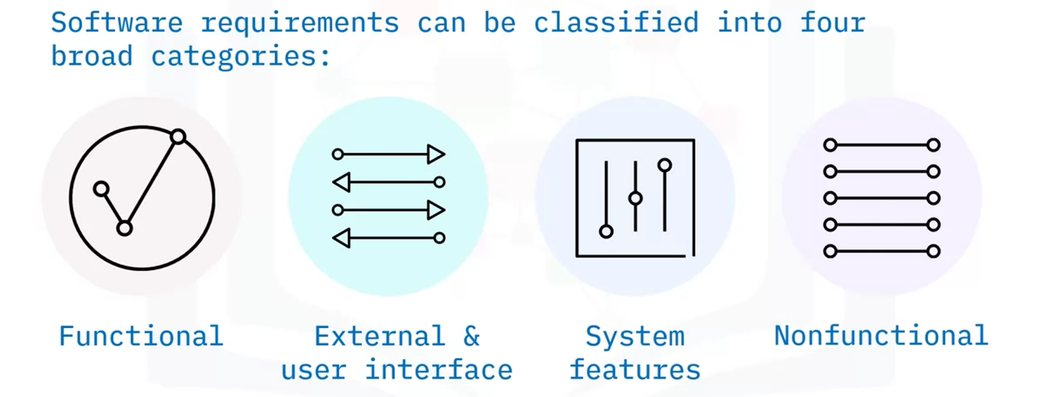
    - 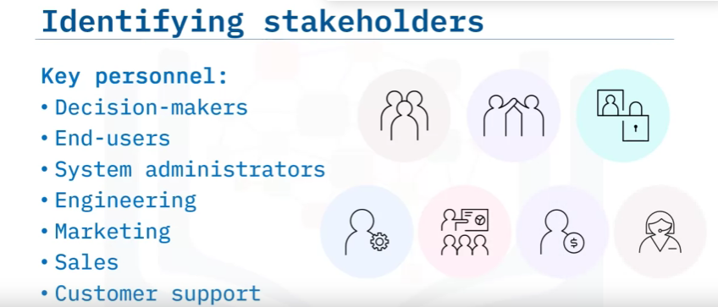
  1. Design:

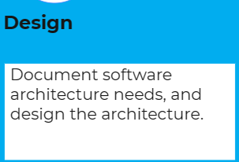

* + - Design, implement the architecture by code.
    - From SRS to sets of related components.
  1. Development:

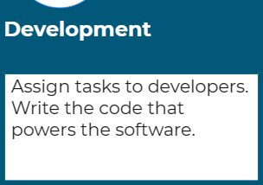

* + - Coding process to approach the design.
  1. Testing:

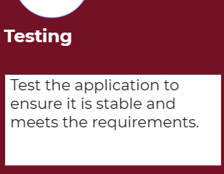

* + - Ensure stability, security, meet requirements of the SRS (software requirements specification).
    - Bug reported, tracked, fixed, retested.
    - Unit, integration, system, user acceptance testing.
  1. Deployment:

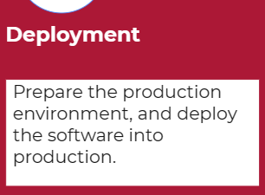

* + - Tested code is deployed for user acceptance testing environments ⇒ store app.
  1. Maintenance:

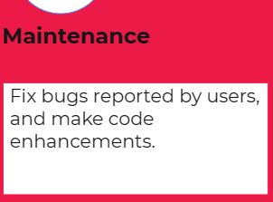

* + - Fix bugs, user interface issues, upgrade system, code enhancements.

# **Releases:**

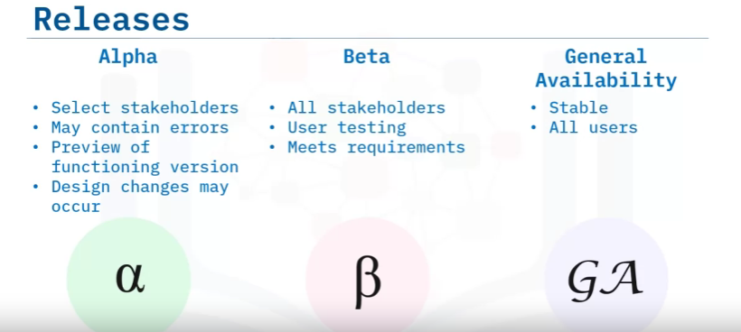

* **Requirements Documentation**
  + Software requirements specification (SRS).
  + User requirements specification (URS).
  + System requirements specification (SysRS).
* **Software version:**

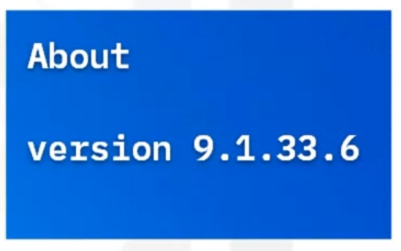

* + With 4 digits ver number:
    - 1st: major change of software (new release).
    - 2nd: minor change to piece of software.
    - 3rd: patches or minor bug fixes.
    - 4th: build numbers, less significant changes.
  + Compatibility (tương thích) with old and new versions is a common problem

# **Software Dev Methodologies:**

## **Sequential:**

1. **Waterfall method:**
   1. Sequential method of software development where output of one phase is the input of the next phase.
   2. Development and work on the next phase start only after the previous is complete.
   3. Customers usually do not see the product until the testing phase.

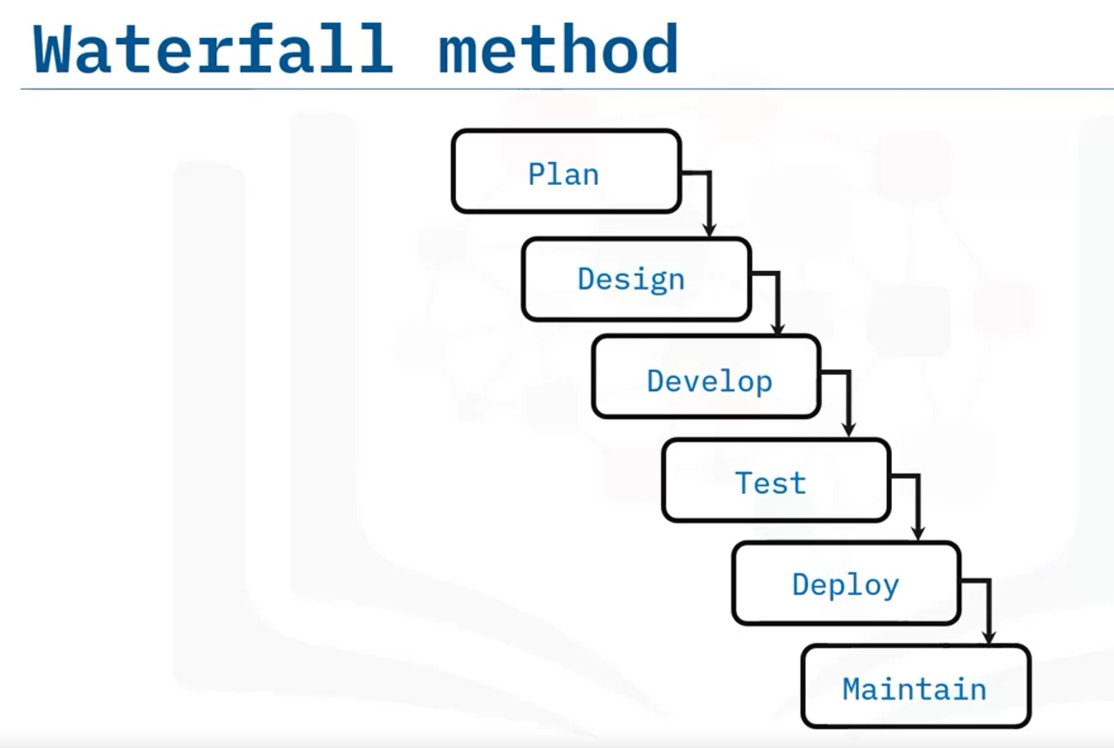

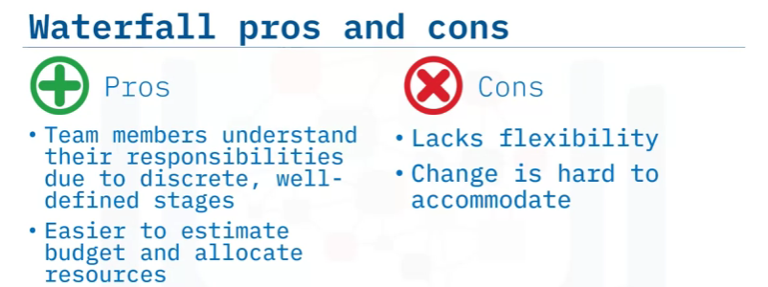

1. **V-shape method:**
   1. The phase going down (left-side) is called **Verification (xác minh)**
   2. The phase going up (right-side) is called **Validation (thẩm định)**

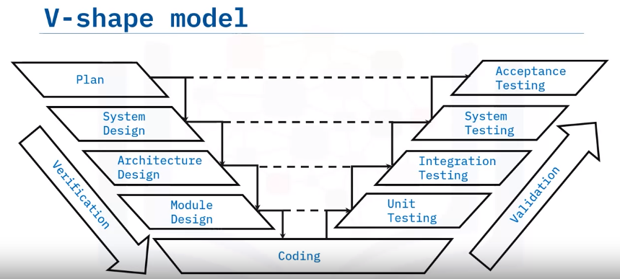

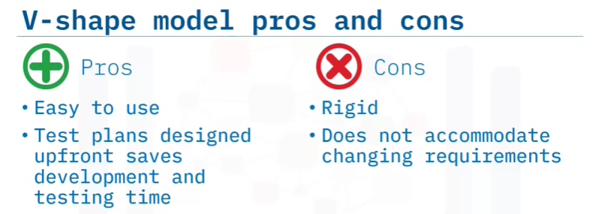

* 1. Four phases from the left correspond to the phases from the right. The tests are written during the verification phases and executed during the validation phase.

## **Iterative:**

1. **Agile**:
   1. Focuses on software development process in short cycles rather than strictly top-down linear process.
   2. Is the iterative approach to dev (tiếp cận lặp đi lặp lại).
   3. Phases are short and work in cycles (1-4 weeks).
   4. Unit testing happens in each phase ⇒ minimise the risk of failure.
   5. After finishing 1 cycle ⇒ demo ver is released to see new func and get feedback from stakeholders.
   6. After several cycles ⇒ a minimum viable product is released ⇒ can change over plan.

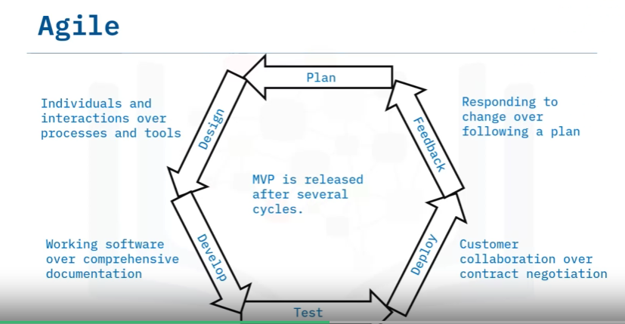

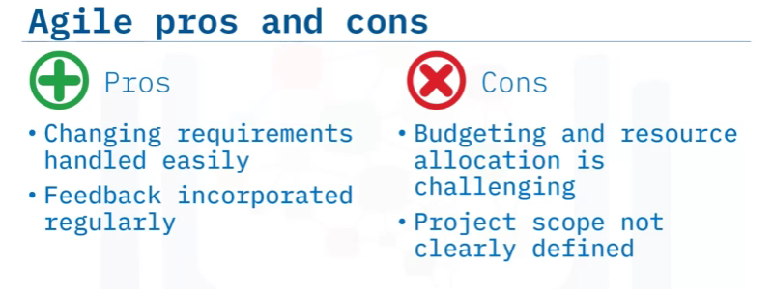

# **Software Testing:**

1. **Defined**:

* Quality checks throughout SDLC.
* Ensure software meet requirements
* Error-free software.

1. **Test case:**

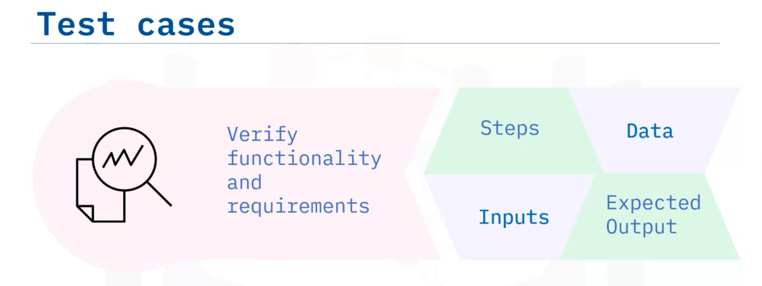

* 1. **Type of testing:**
     1. **Functional testing**
        + 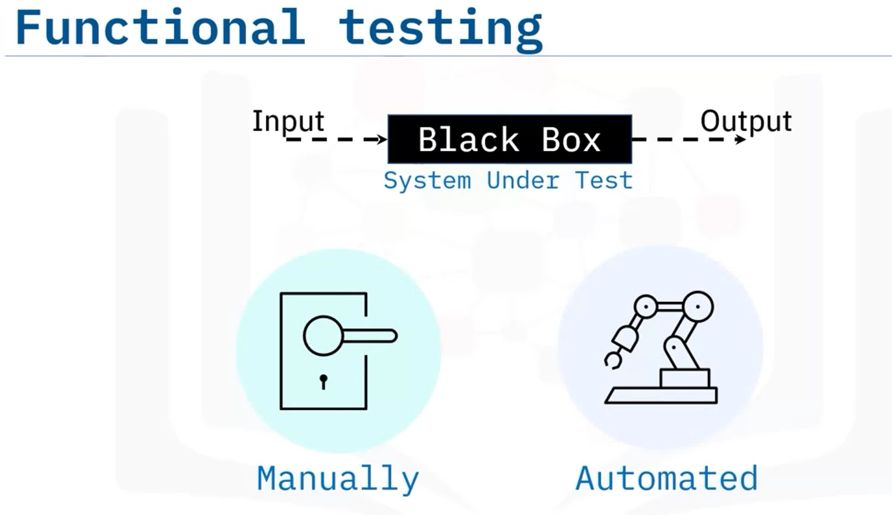
        + Make sure the application is usable and accessible.
     2. **Non-functional testing**
        + 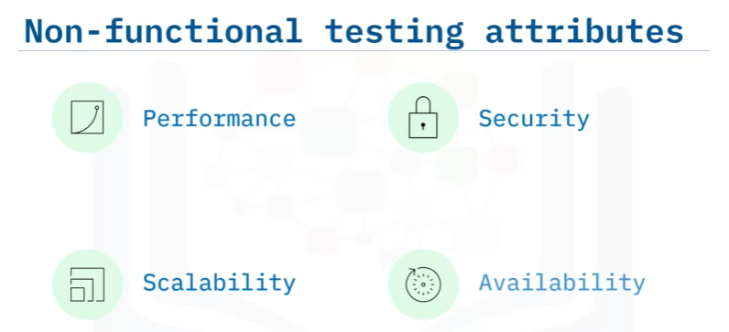
        + 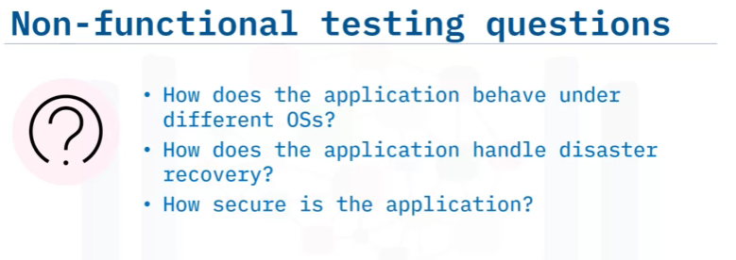
     3. **Regression testing**
        + 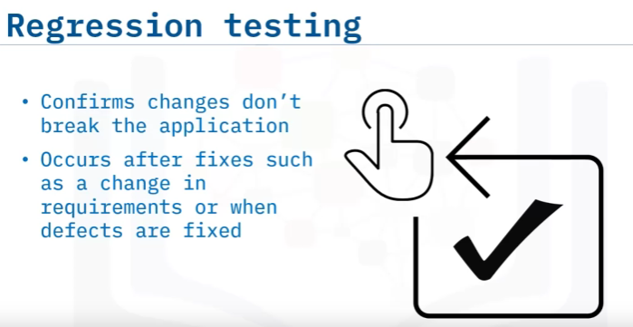
        + 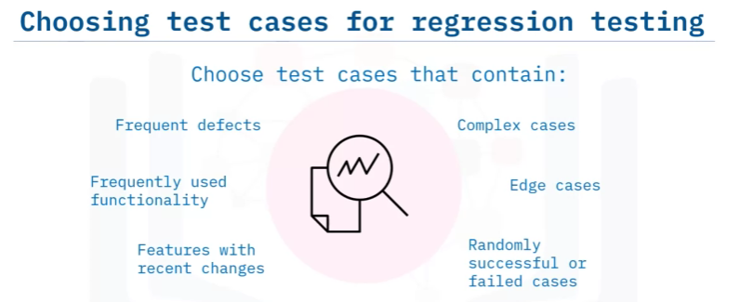
     4. **Testing levels**
        + **4 levels of testing: unit, integration, system, acceptance testing.**
        + **Unit testing:**
          - 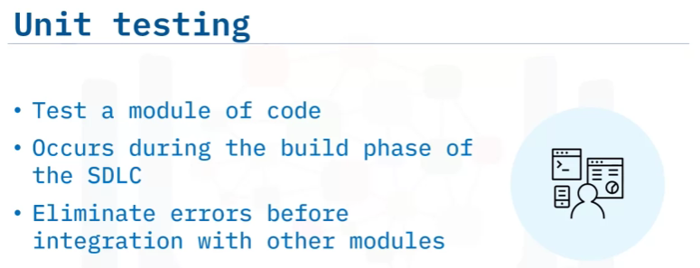
        + **Integration testing:**
          - 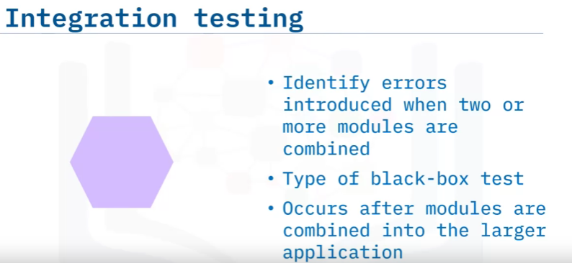
          - **Make sure all modules when combined are not occur problems:**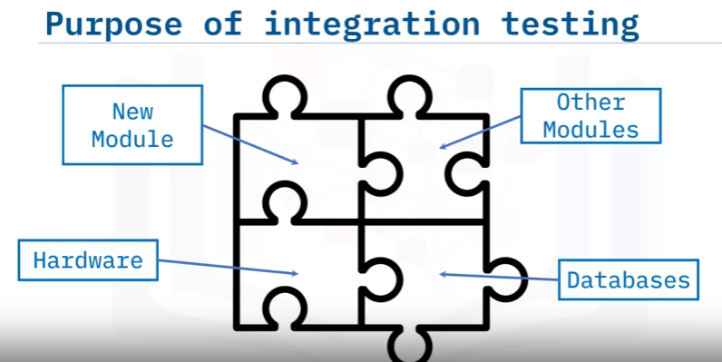
        + **system testing:**
          - 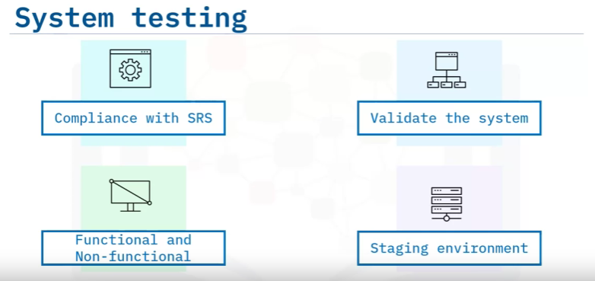
        + **acceptance testing:**
          - Done by users, customers and stakeholders.

# **Role in Software Engineering PJ:**

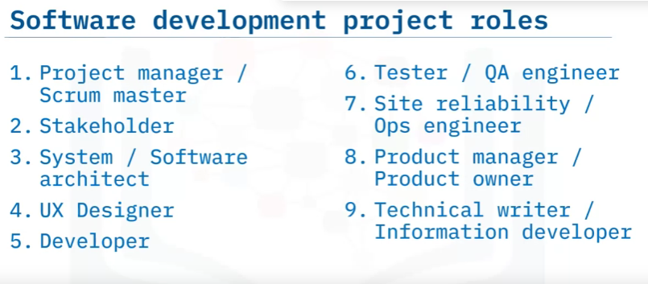

### Pj manager / scrum master:

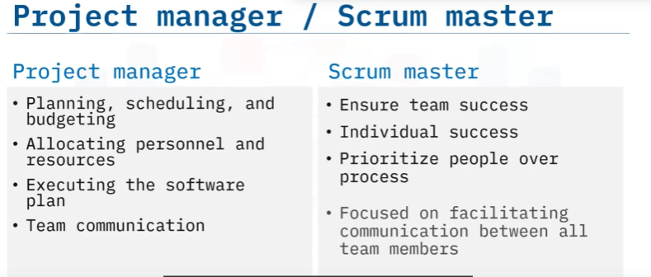

### Stakeholder:

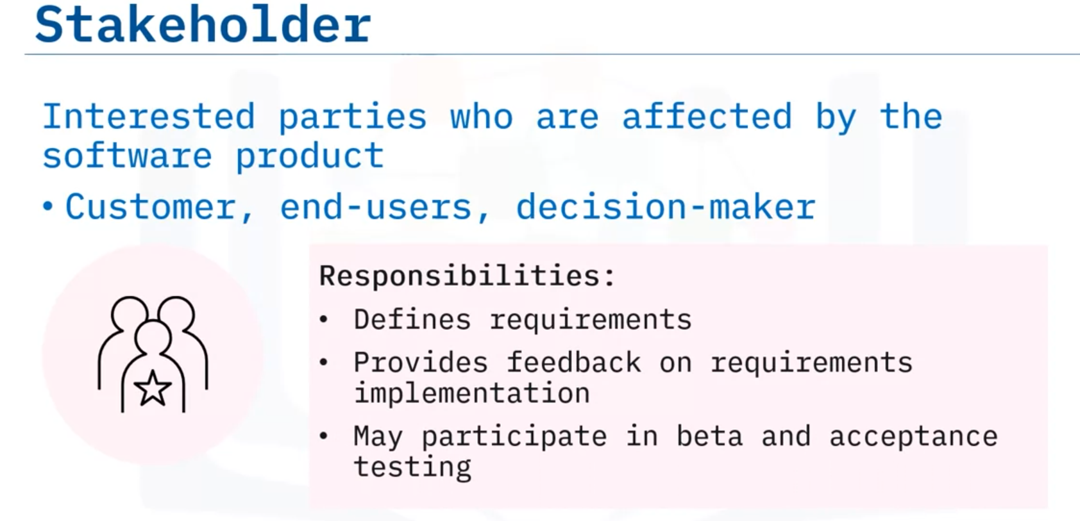

### System architect:

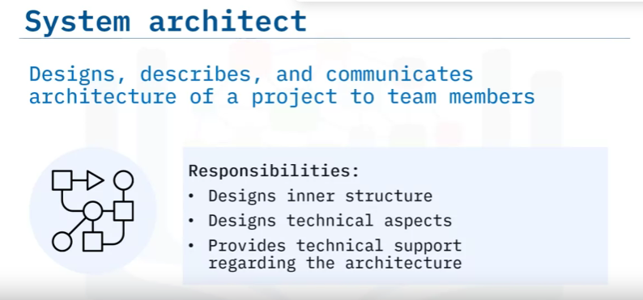

### UX designer:

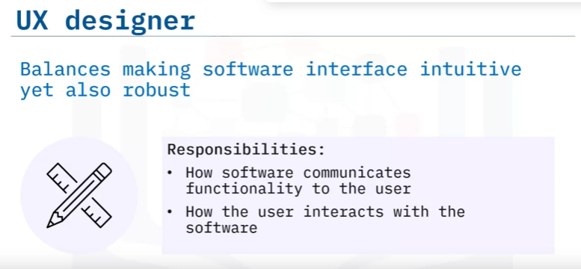

### Developer:

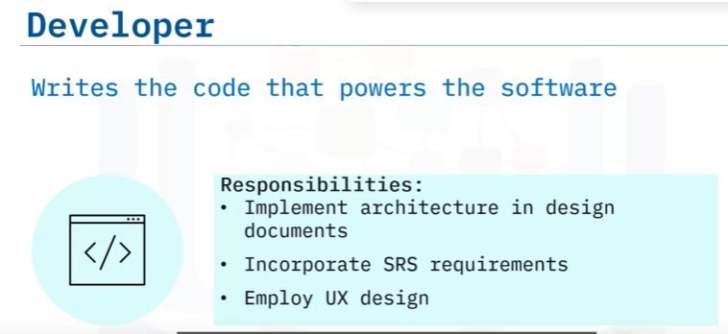

### Tester / QA engineer:

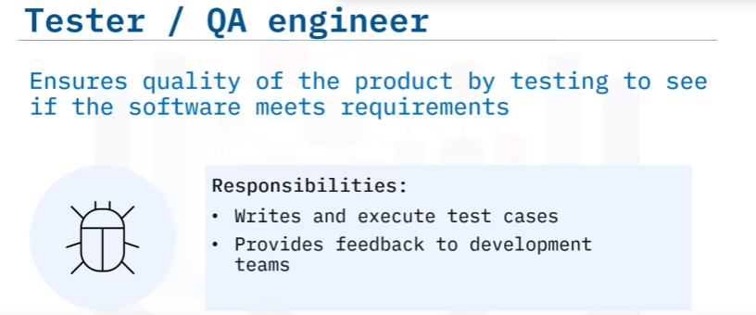

### Site reliability engineer:

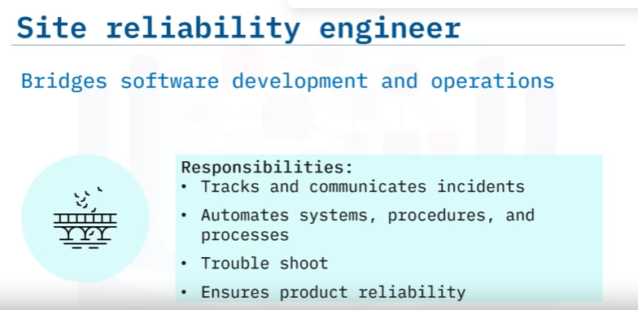

### Product manager / product owner:

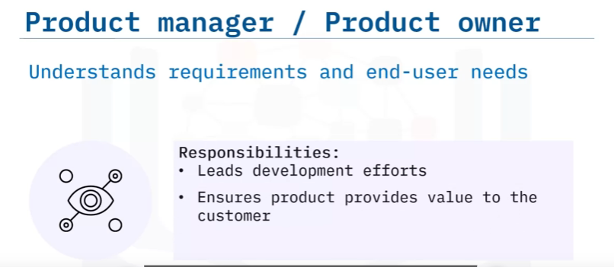

### Technical writer / Information developer:

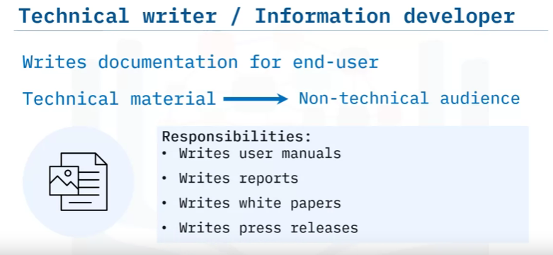

# **Web and Cloud Development**

## **Website:**

When we request / interact with a website: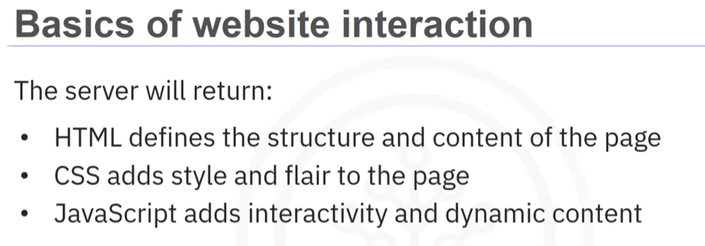

### Most websites contain **static** and **dynamic elements** to provide the best user experience.

* **Static Element:** previously stored on the server
  + HTML, CSS, JS
* **Dynamic Element:** generate each time when they are requested by clients.
  + HTML, CSS, JS, PHP, CMS, Database.

### Most websites are designed as reactive and responsive.

## **Cloud app:**

* Build to work seamlessly with a Cloud-based back-end infrastructure.
* Data storage and processing, other services very scalable (mở rộng) and resilient (linh hoạt).

## **Front-end:**

* Deal with everything that happens at client-side.
* HTML: create the physical structure of a website: text, link, img, video,...
* CSS: create stylish websites with colour, font, style, cross browser compatibility.
* JS: used to add interactivity to a website.
* SASS (CSS extension) ⇒ compiler ⇒ CSS: more powerful func.
* LESS (Learner Style Sheet) ⇒ Less.js ⇒ CSS: more style and func.
* 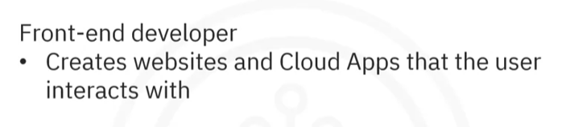

## **JavaScript frameworks:**

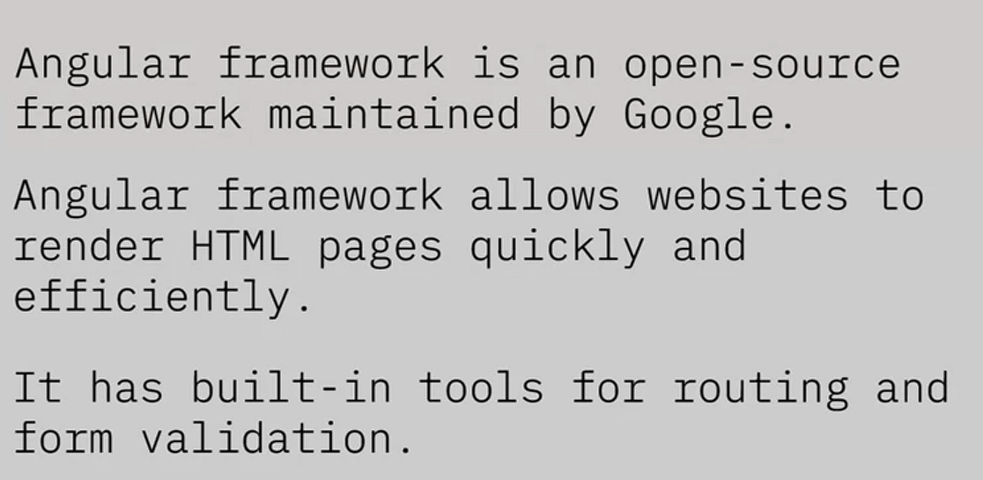

* React.js (Facebook): build and render components for a web page.
* Vue.js: focus in the view layer (user interface, button, visual components).
* Can be both lib or framework ⇒ very adaptable, flexible, scalable.

## **Back-end:**

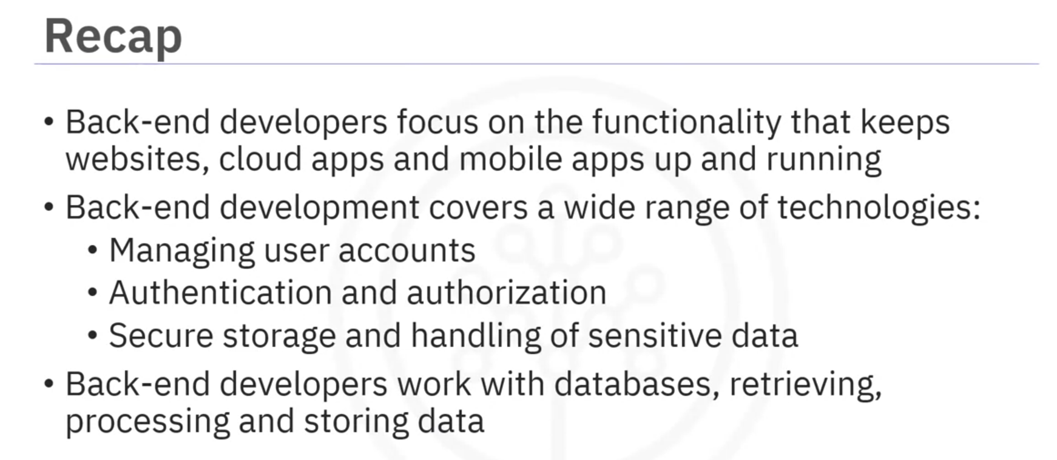

* Deal with the server before the code and data are sent to the client.
* Handle the logic, func and authentication processes that keep data secure.
* Relational or noSQL databases.
* 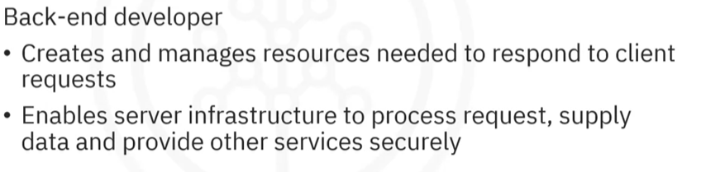
* Process the data users enter while browsing

#### API, routing, endpoints:

* + API: code works with data (Json, XML), is a set of rules and structures.
  + Route: path to a website or page.
  + Endpoint: API or Route. (404 Error occur when Endpoint not found).
  + We must create routes to direct requests to the correct service.

## **Teamwork: 5 state**

* Kick-off: plan how the project will be completed.
* Design and code review.
* Walkthroughs
* Retrospectives: review what is well and what will be improved in the future.
* Mentoring.

## **Programing Languages:**

* **Interpreted programming:** lập trình thông dịch
  + HTML, Python, JavScripts
  + Translate human-readable line by line scripted code to interpreter. ⇒ run code.
* **Compiled programming:** lập trình biên dịch
  + The program is packaged or compiled into one executable file.
  + C, C++, C#, Java
* Different:
  + 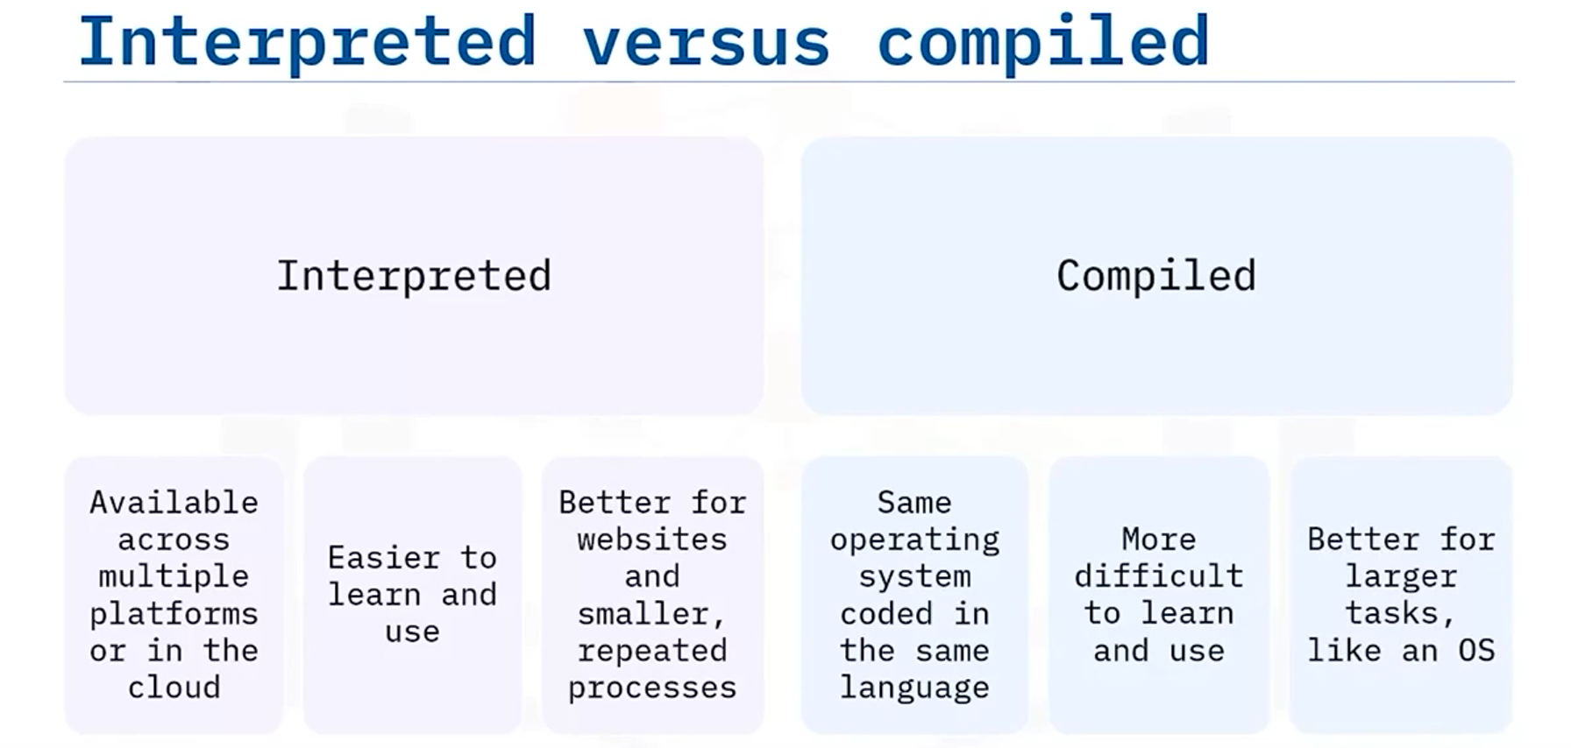

## **Query Languages:**

* Is a request for information from a database.
* The database searches its table ⇒ returns requested results.
* CRUD: Create, read, update, delete.
* SQL, AQL, CQL, Datalog, DMX
* SQL and NoSQL
  + 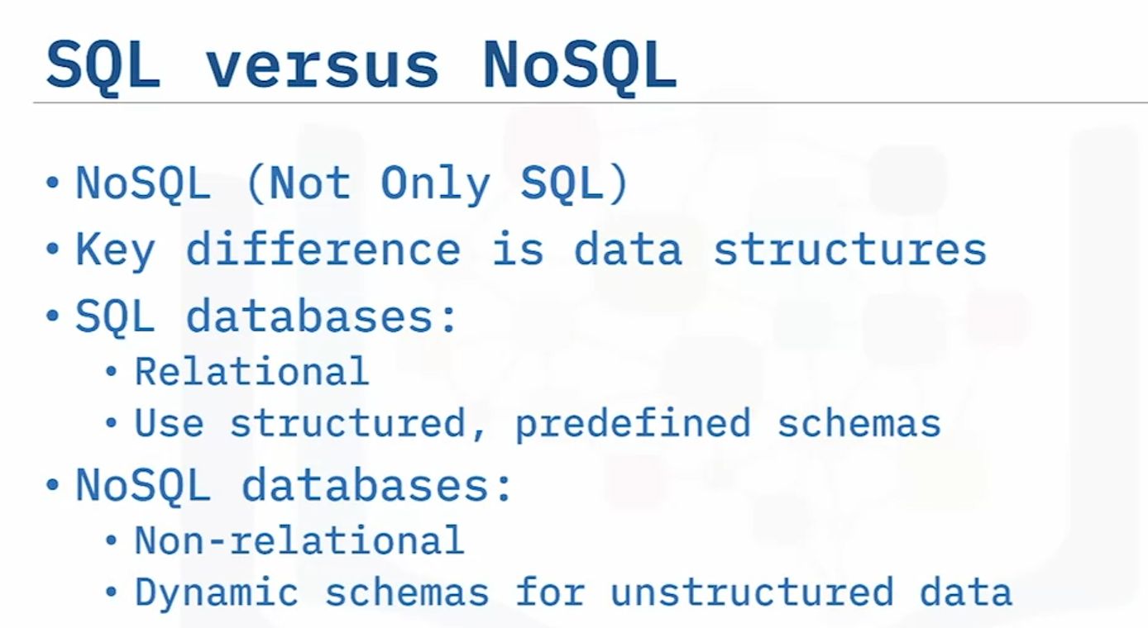

## **Code Organization:**

* Readability, Maintainability, Configuring.
* 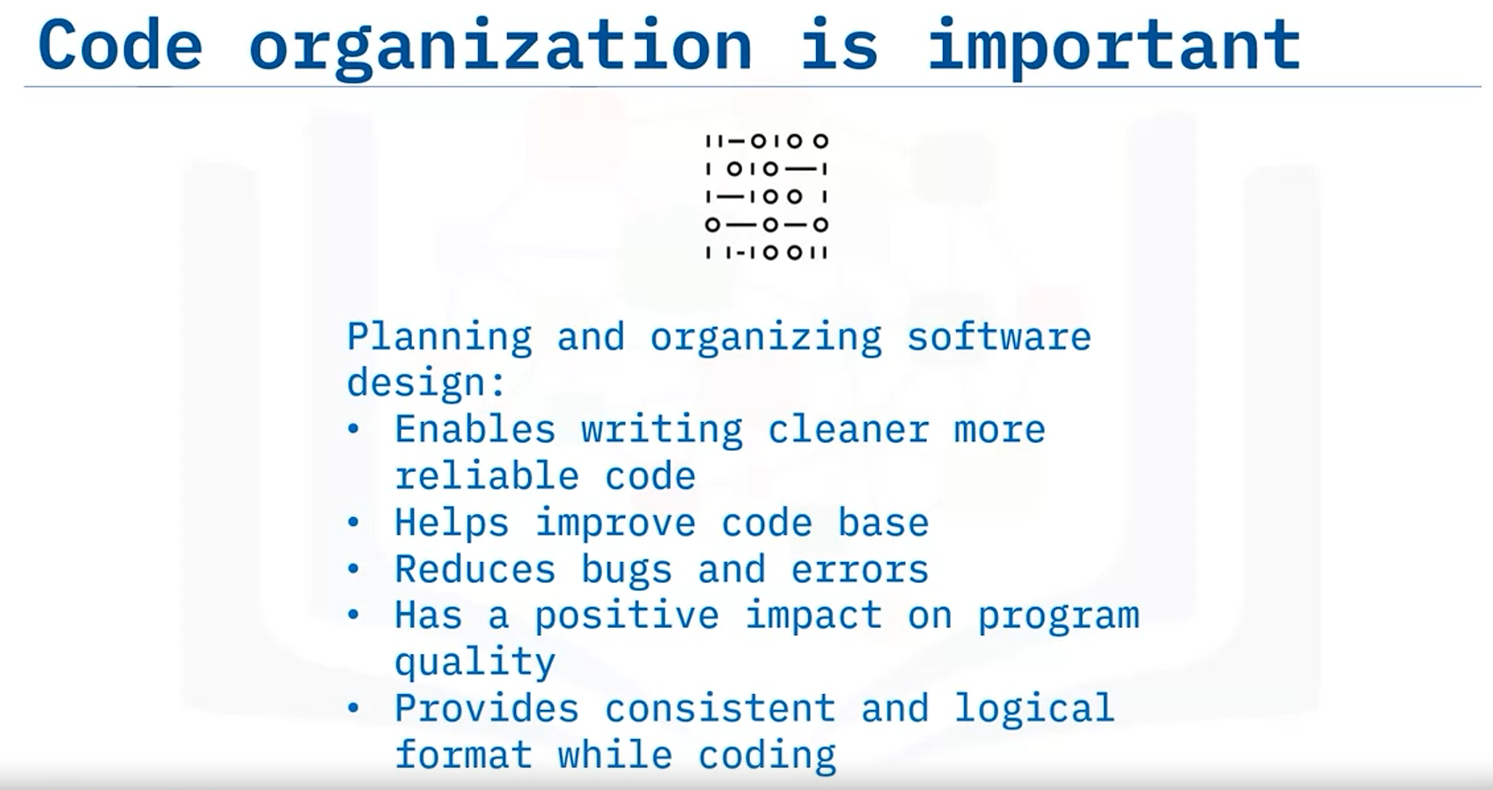
* 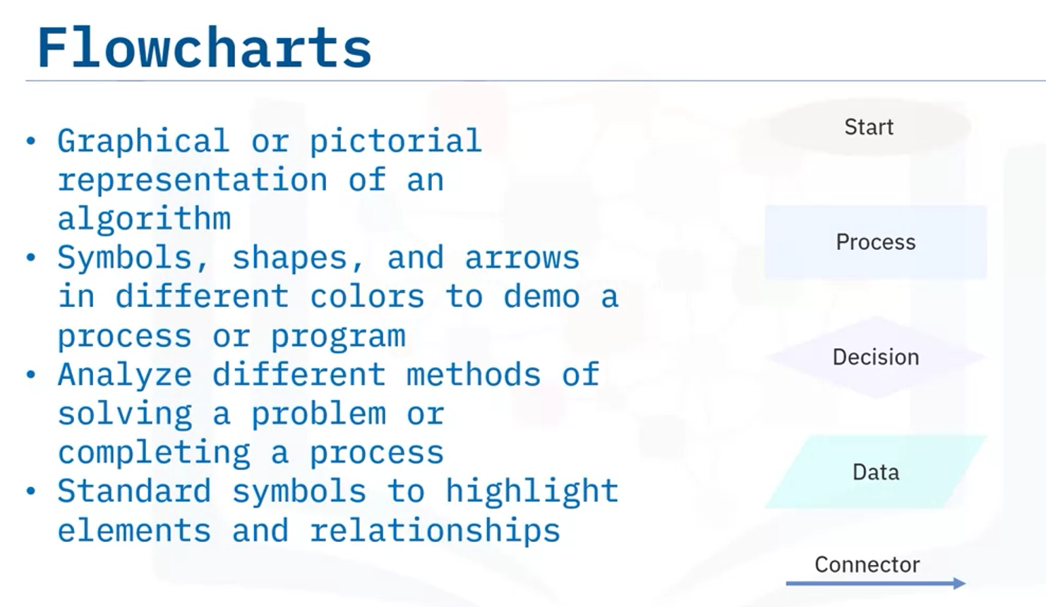

## **Branching and Looping:**

* Branching:
  + Boolean expression
  + Variable
  + Decision making
  + 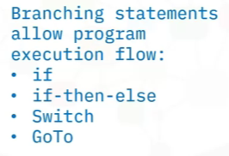
* Looping:
  + 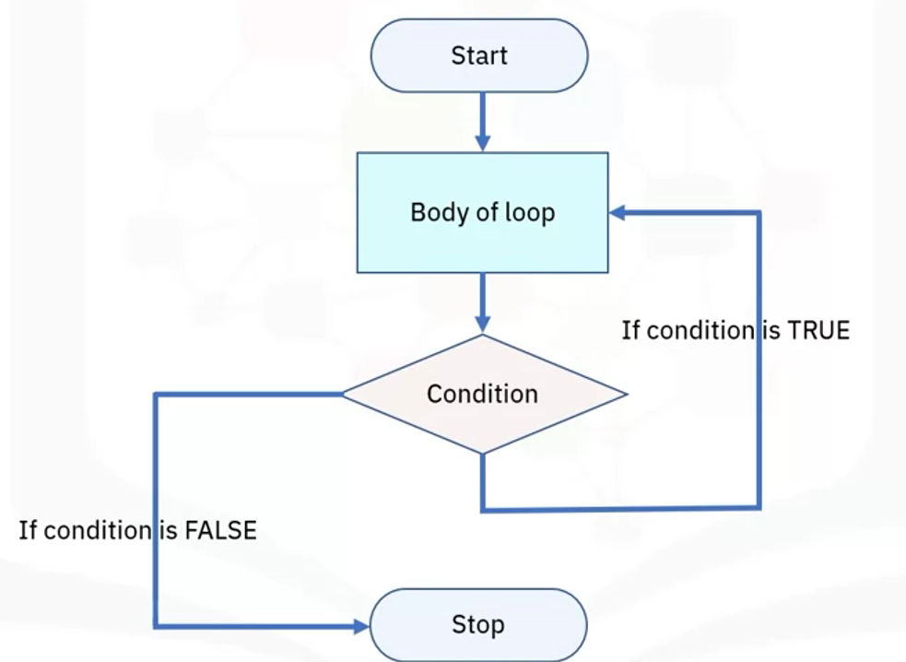
  + 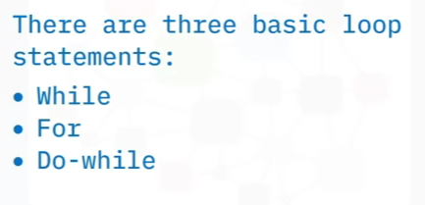

## **Software Architecture:**

* Is the organisation of the system.
* Servers as a blueprint for dev.
* 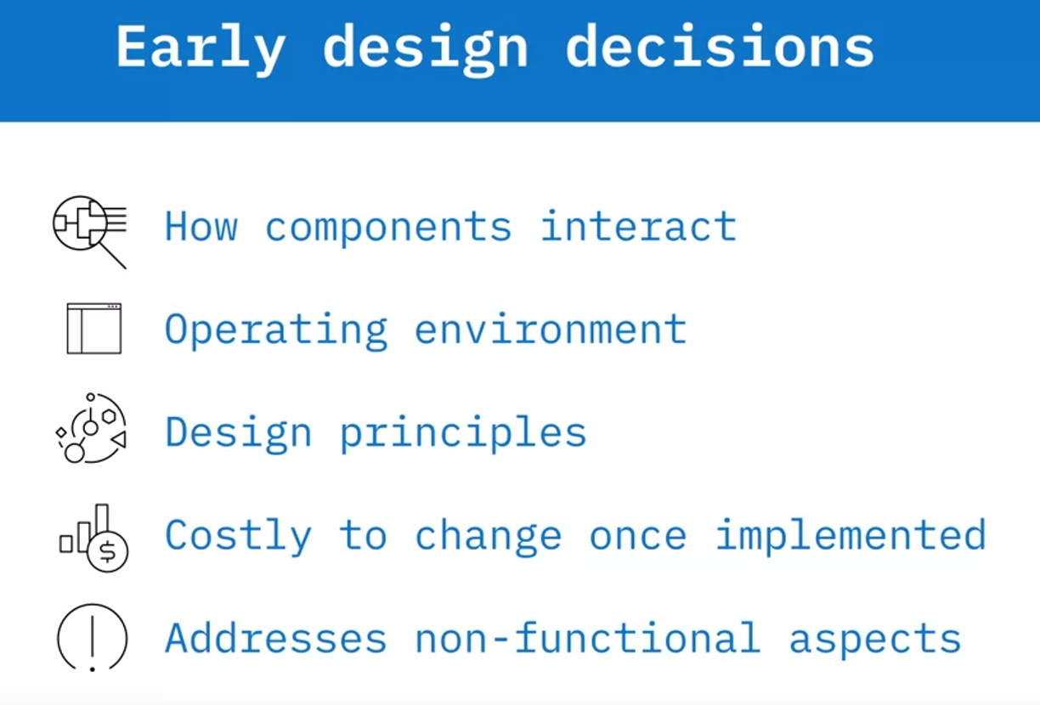
* 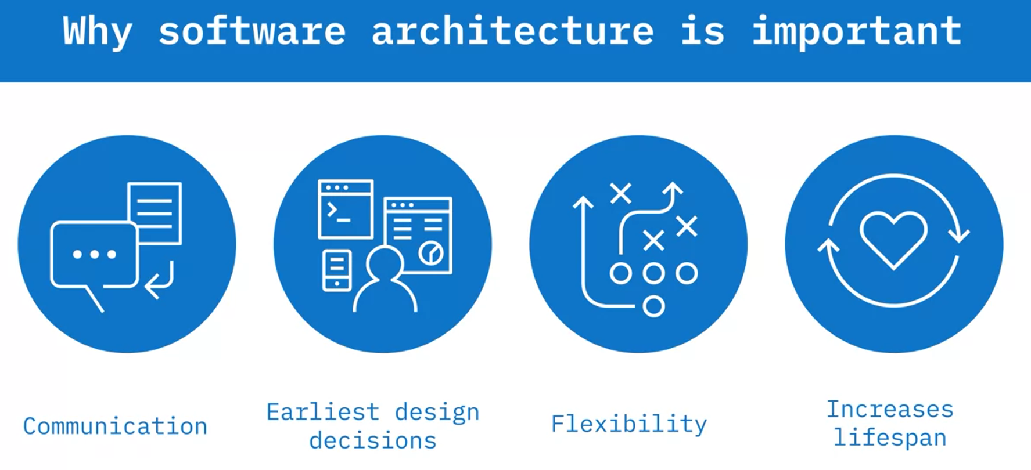
* 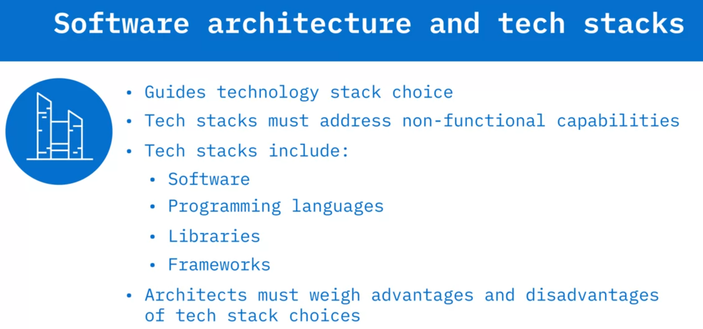
* 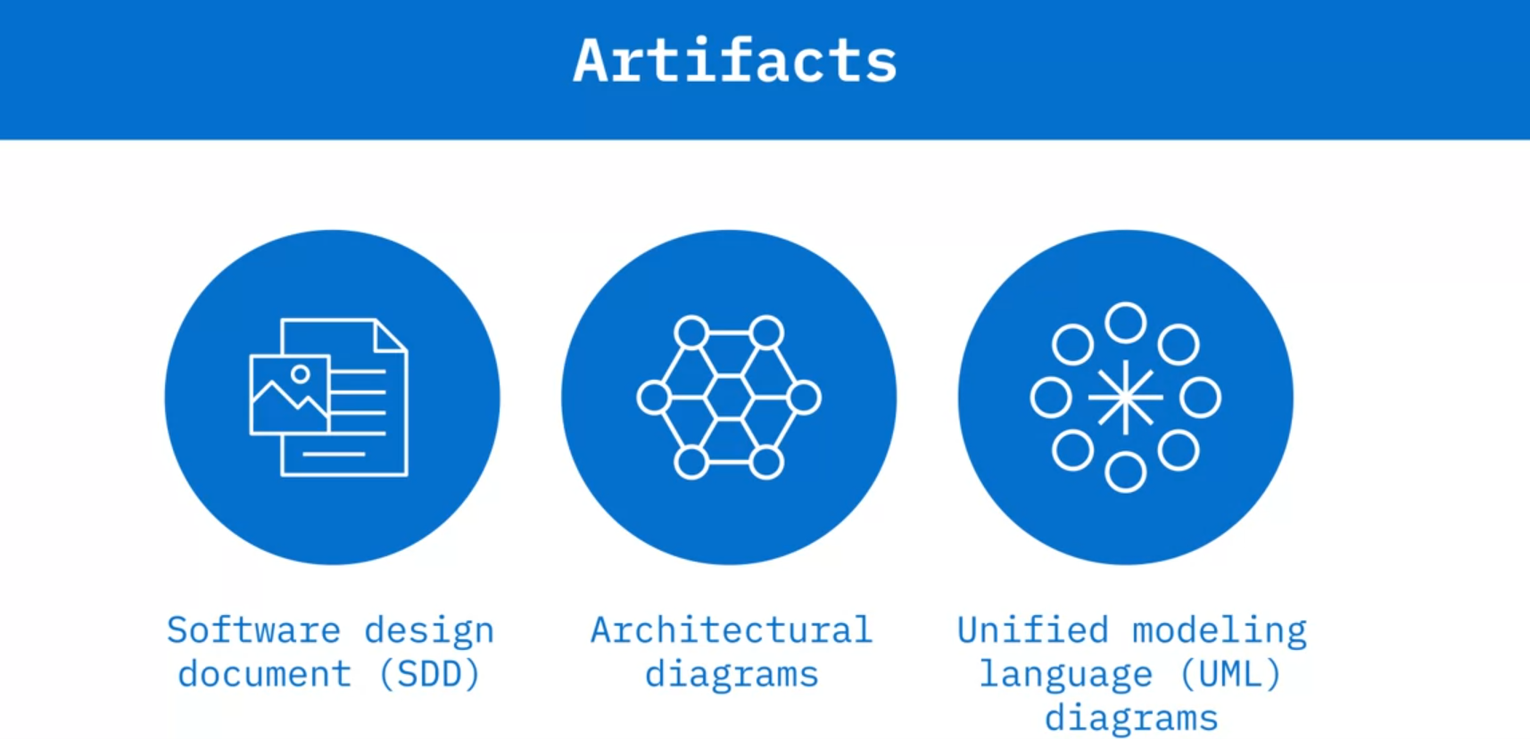
* SSD: Collection of tech specs regarding design implementation.
  + Assumptions, dependencies, constraints, requirements, objectives, methodologies.
* AD: Display the architecture patterns used in the design.
  + Components, Interactions, constraint, confines, architectural patterns.
* UML: Visual communication structure and behaviours.

## **Software Design and Modeling:**

* 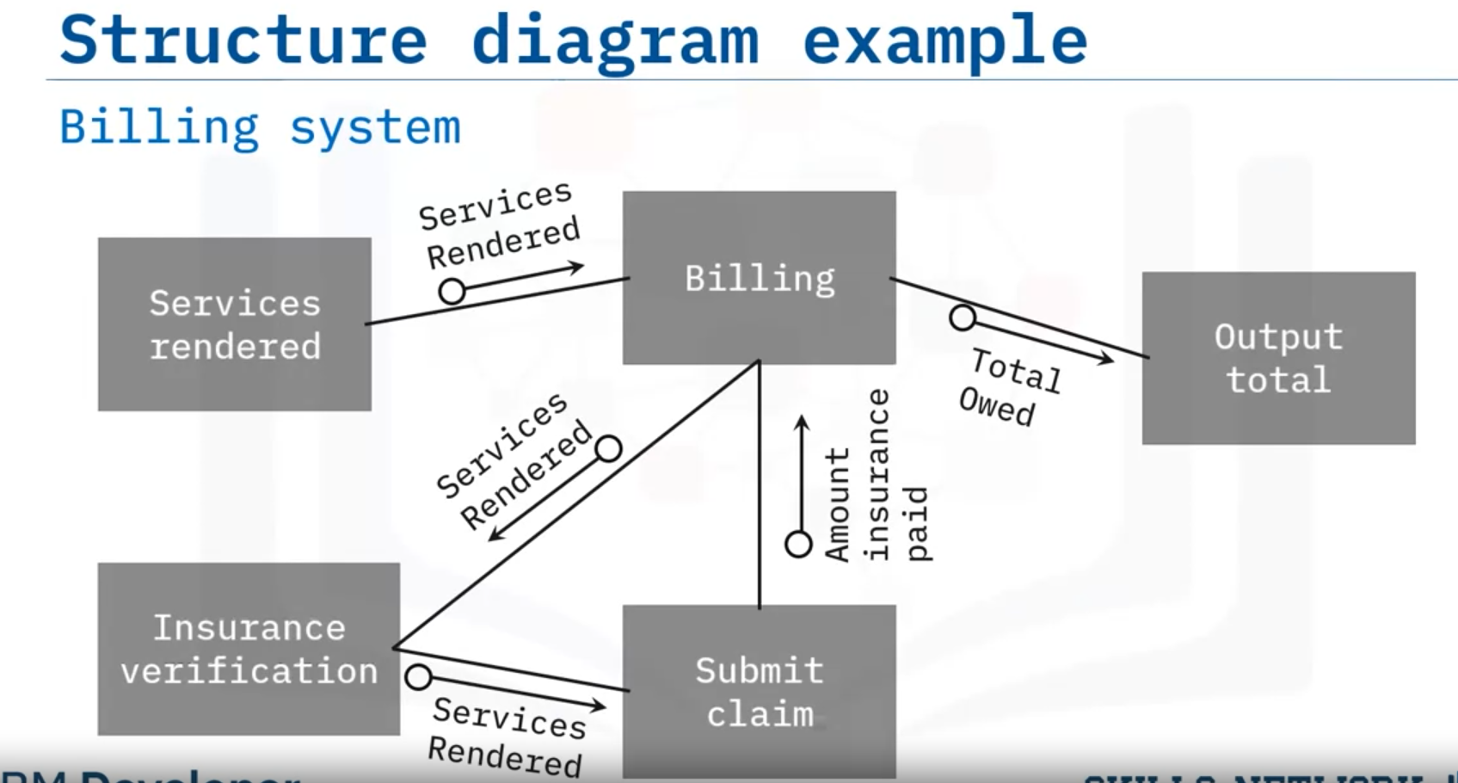
* 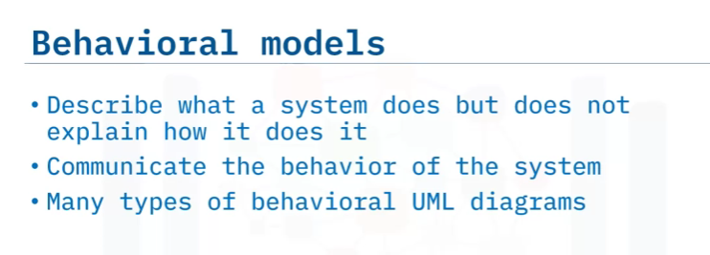

## **Object-oriented languages:**

* An object contains data and can perform actions.
* Anything could be an object.
* Class is a blueprint - template for an object => object is an instance of Class.
* 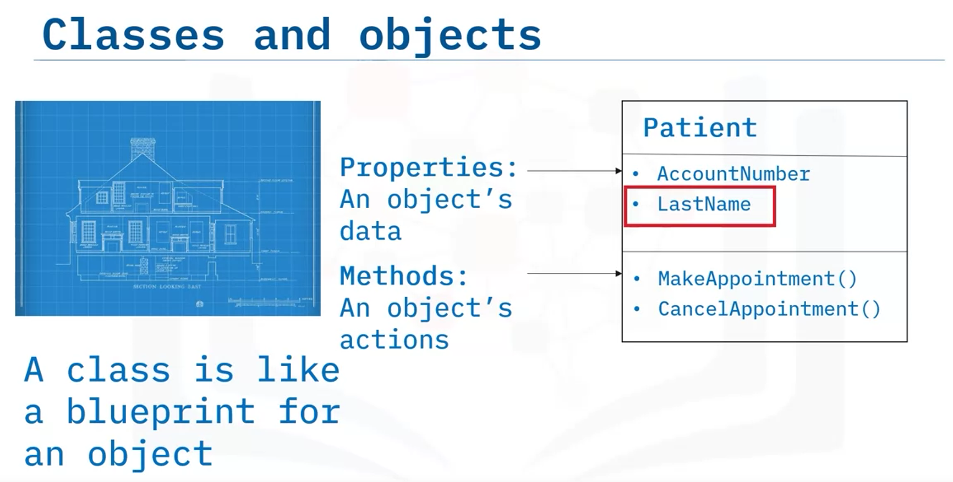

## **Application Architectures:**

### Component:

* + Characteristics:
    - Reusable, replaceable, independent, extensible, encapsulation, non-context specific
    - 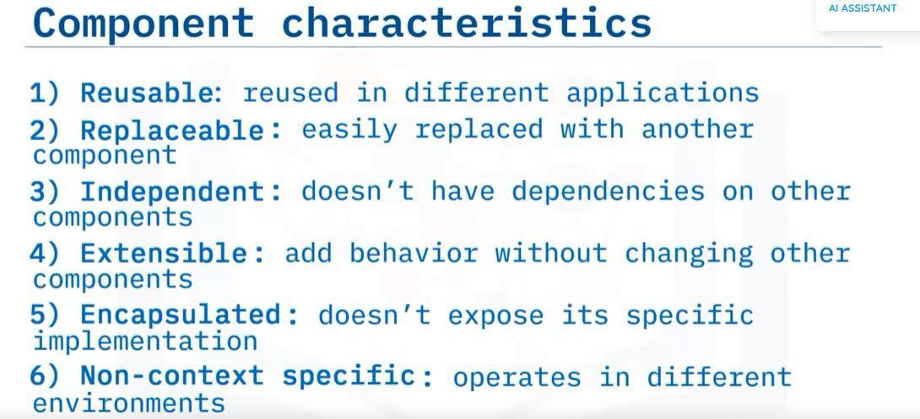
    - Example: API, Data Access Object, Controller,...

### Services:

* + Is a component but it is unique in each project. Alway run.
  + 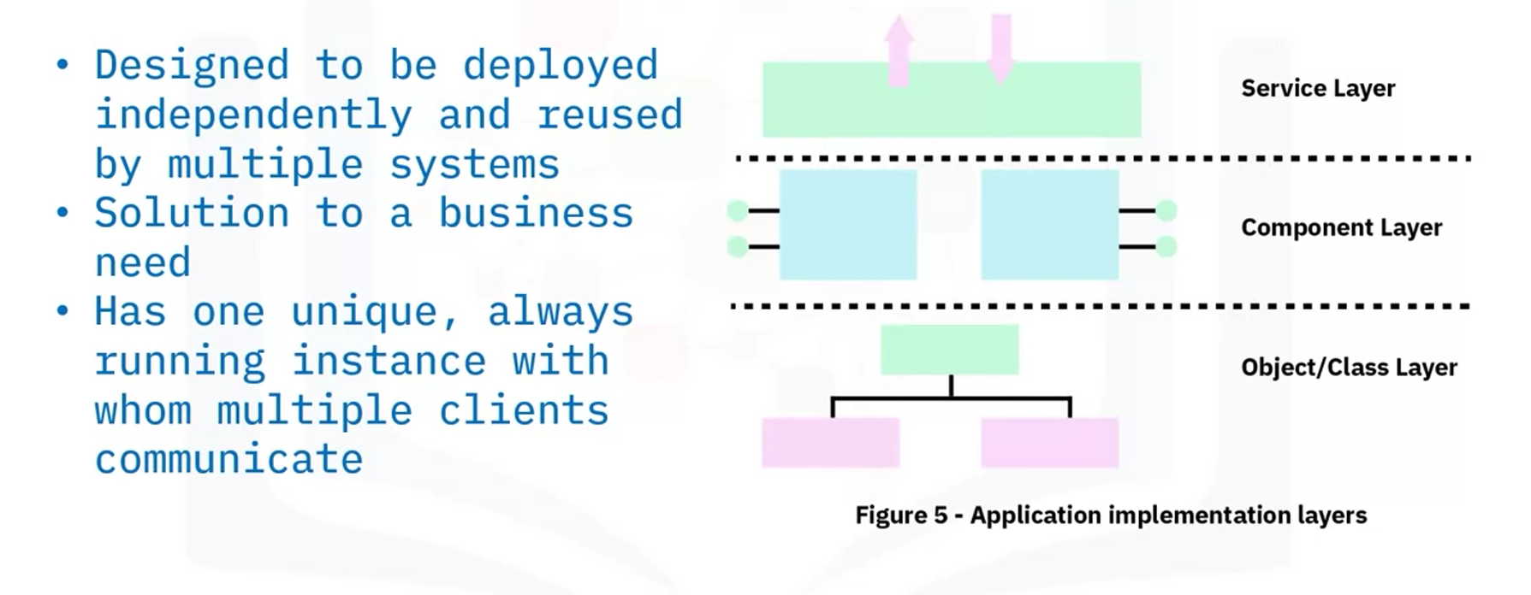
  + Example: checking customer’s credit, process an application
  + service -oriented architecture:
    - Loosely coupled services that communicate over a network.
    - Support building distributed systems through the communication protocol

#### Distributed system:

* + - 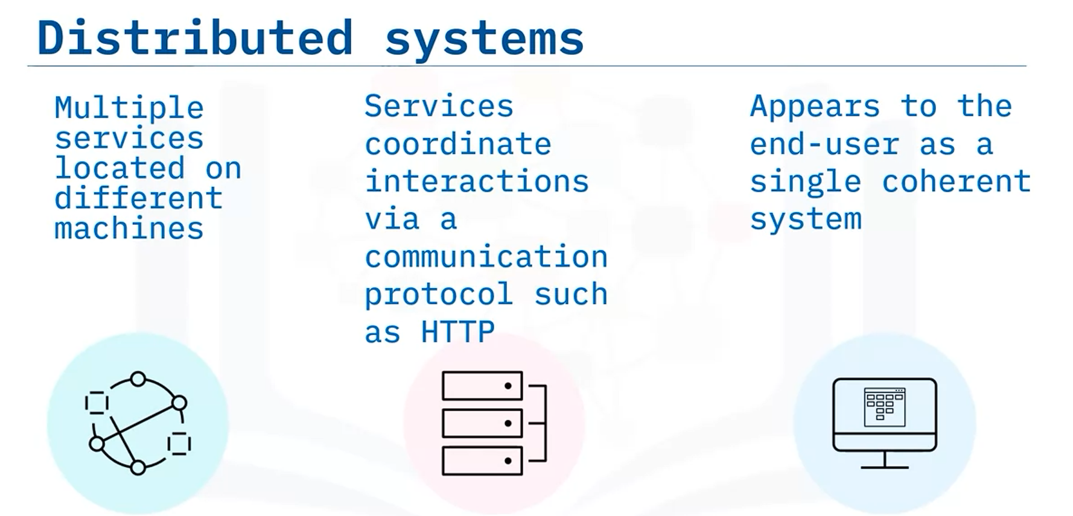
    - Characteristics:
    - 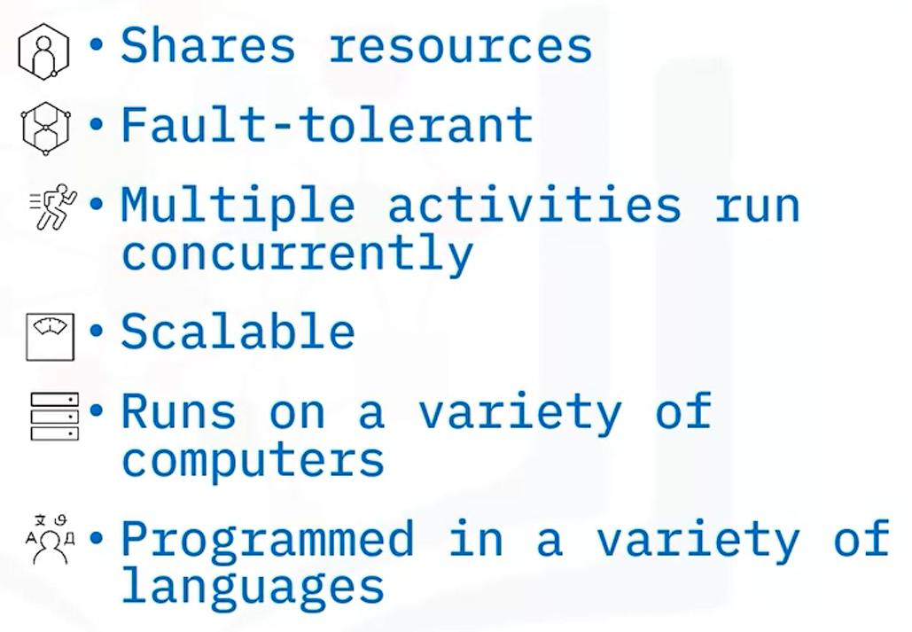
    - Some distributed systems architecture models:
    - 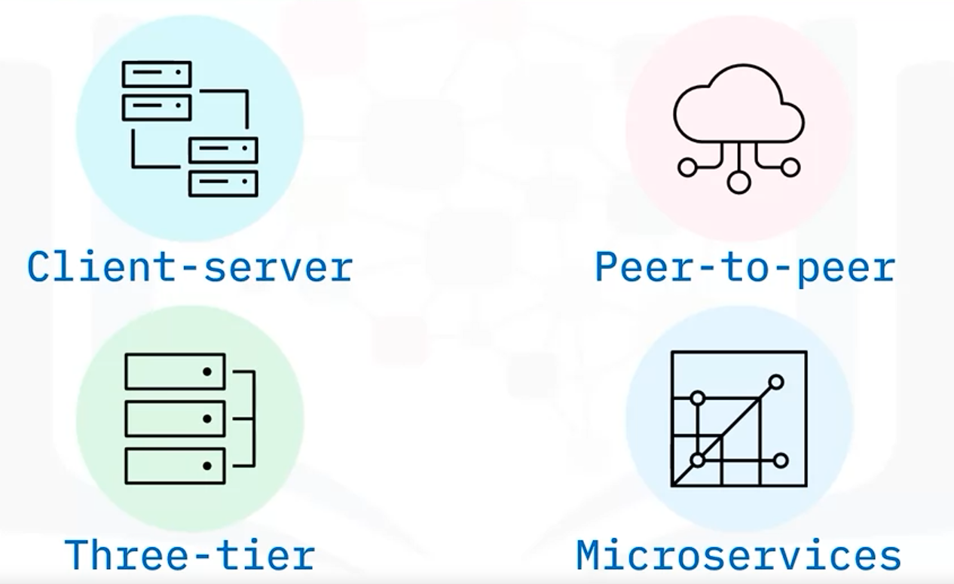

### Architectural patterns:

* + 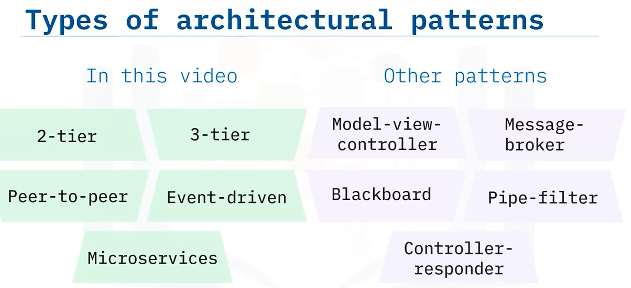
  + 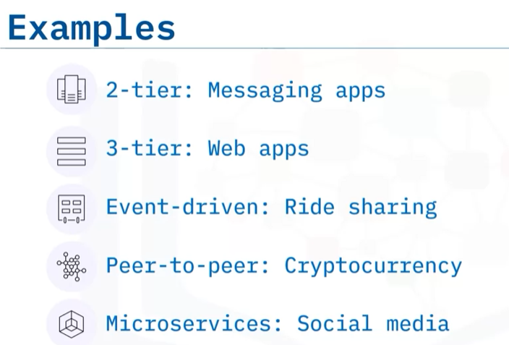

#### 2-tier architecture:

* + - Client - Server architecture
    - Server host, delivers, manages most of the resources and services.
    - 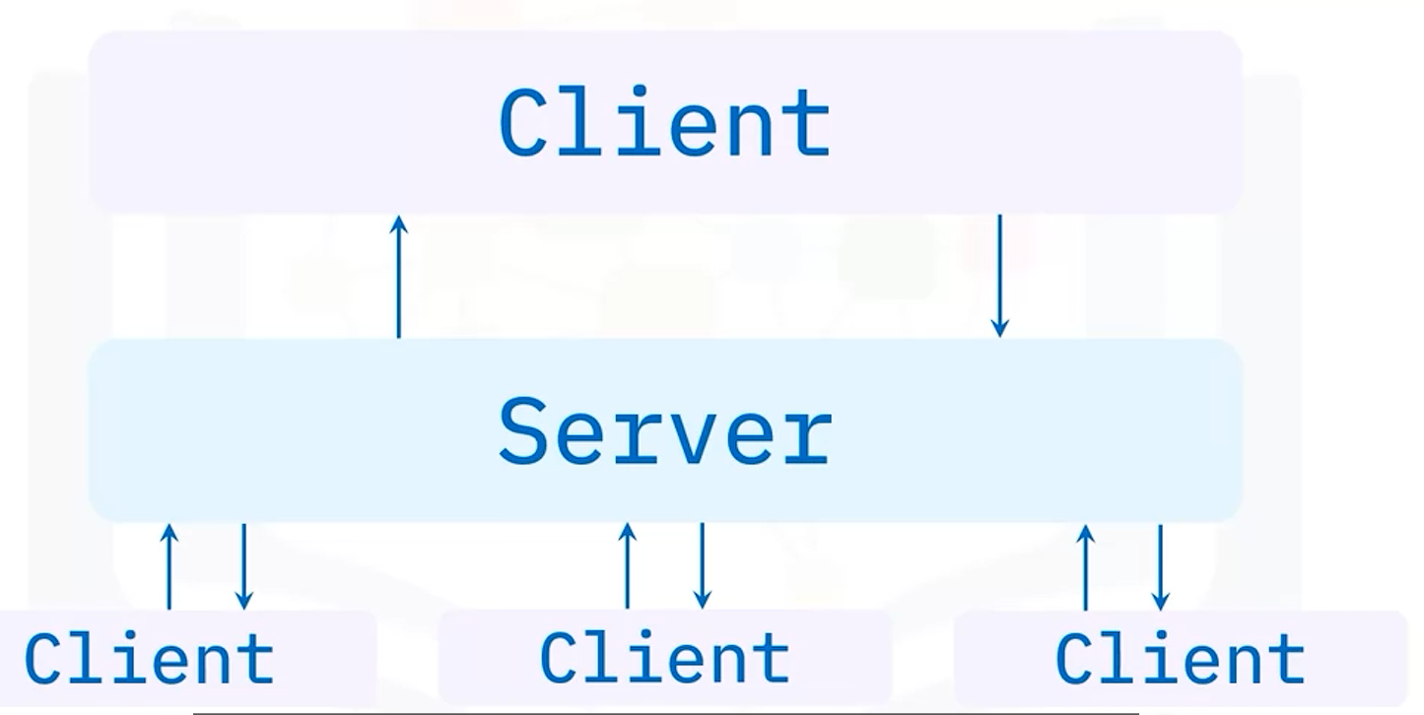

#### 3-tier architecture:

* + - Most common architecture
    - 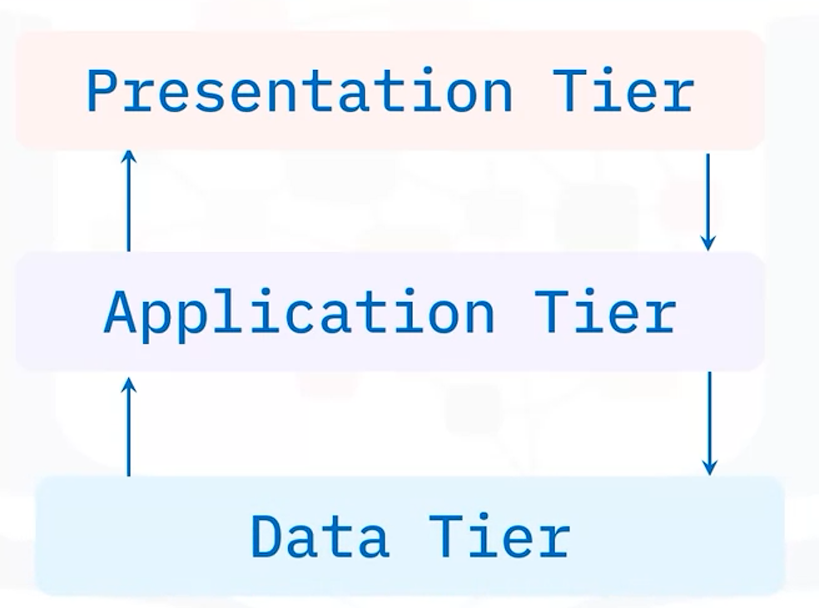

#### Peer to peer architecture (P2P):

* + - Participants communicate directly with others.
    - Without central coordination by server.
    - Useful for file sharing, instant messaging, collaboration, high performance computing.
    - 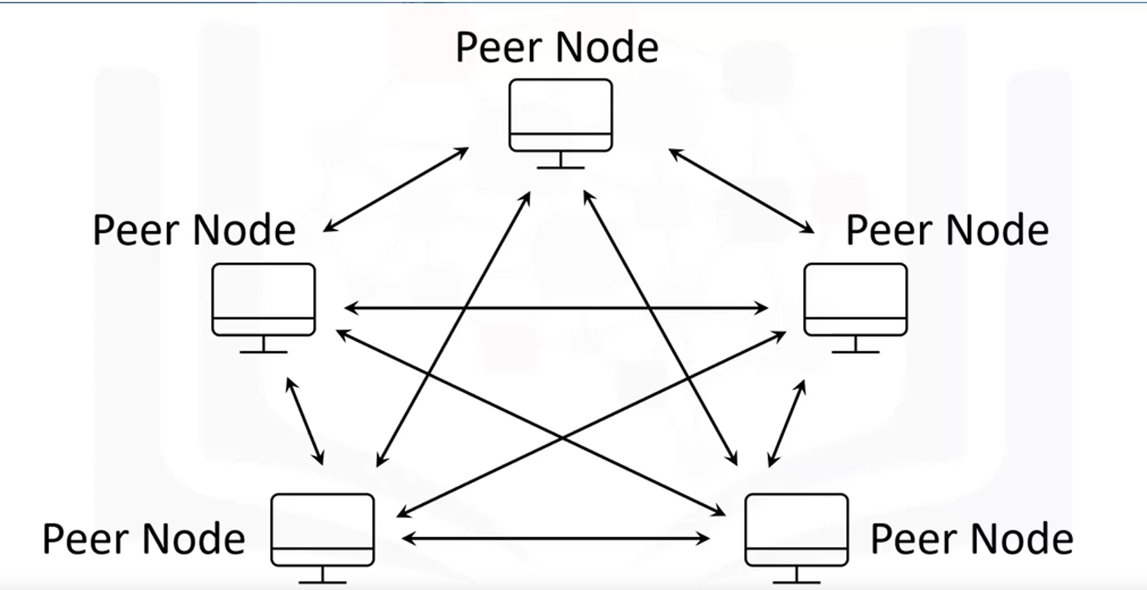

#### Event-driven:

* + - 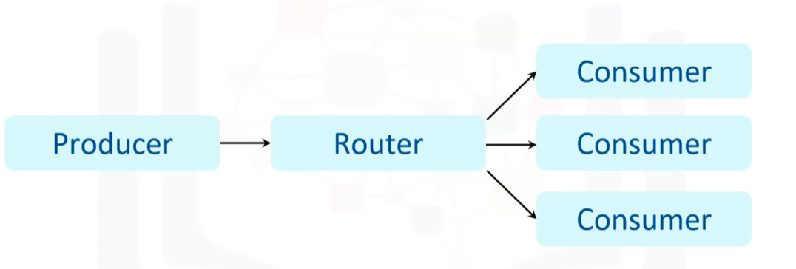
    - Producers push each event to each consumer.

#### Microservices:

* + - Each functionality is a modular component (service).
    - API is used to build the base of this architecture.
    - 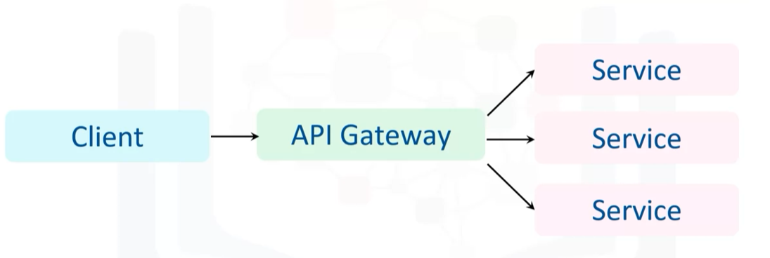

## **Application Deployment environment:**

### Application Environment:

* + The combination of the hardware and the software resources required to run the app.
  + 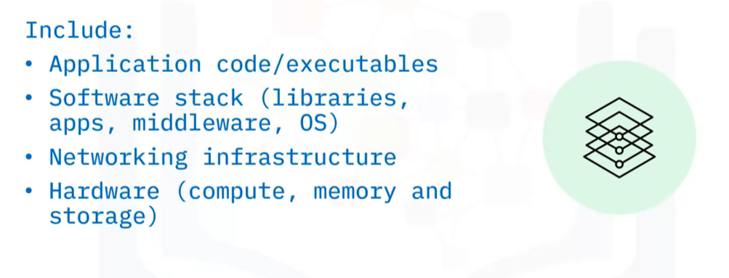

### pre-production Environment:

* + 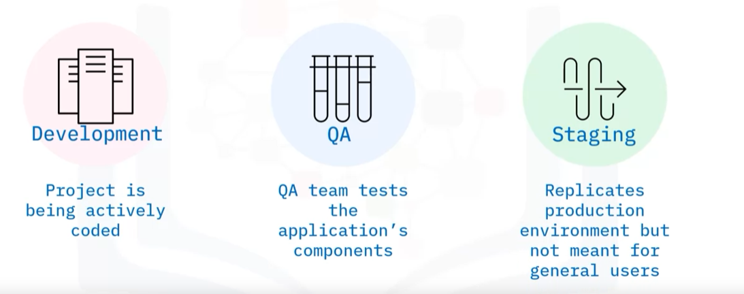

### Production Environment:

* + Include: Entire solution stack, intended for all users, take load into consideration, security, reliability, scalability, more complex than pre-production.

### On-premises deployment:

* + System and infrastructure reside in-house, behind the firewall to prevent unauthorised access.
  + Greater control of the app.
  + Organisation for everything like hardware, system,...
  + More Expensive than cloud deployment.

### Cloud deployment:

* + Public, Private, Hybrid mode.
  + 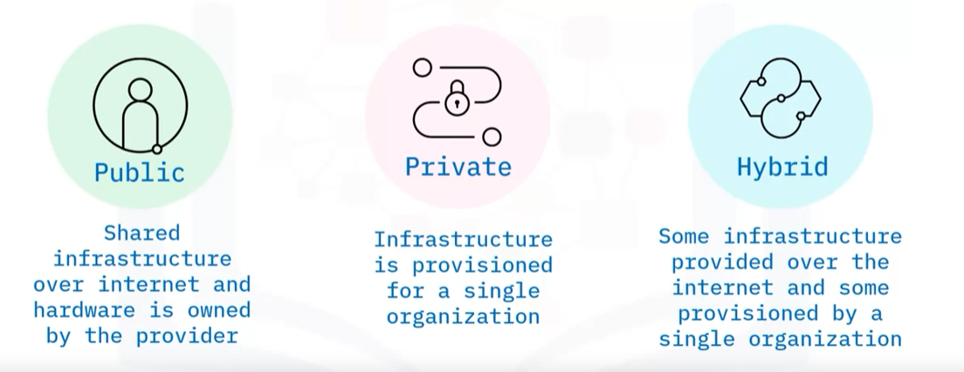

## **Production Deployment Components:**

* 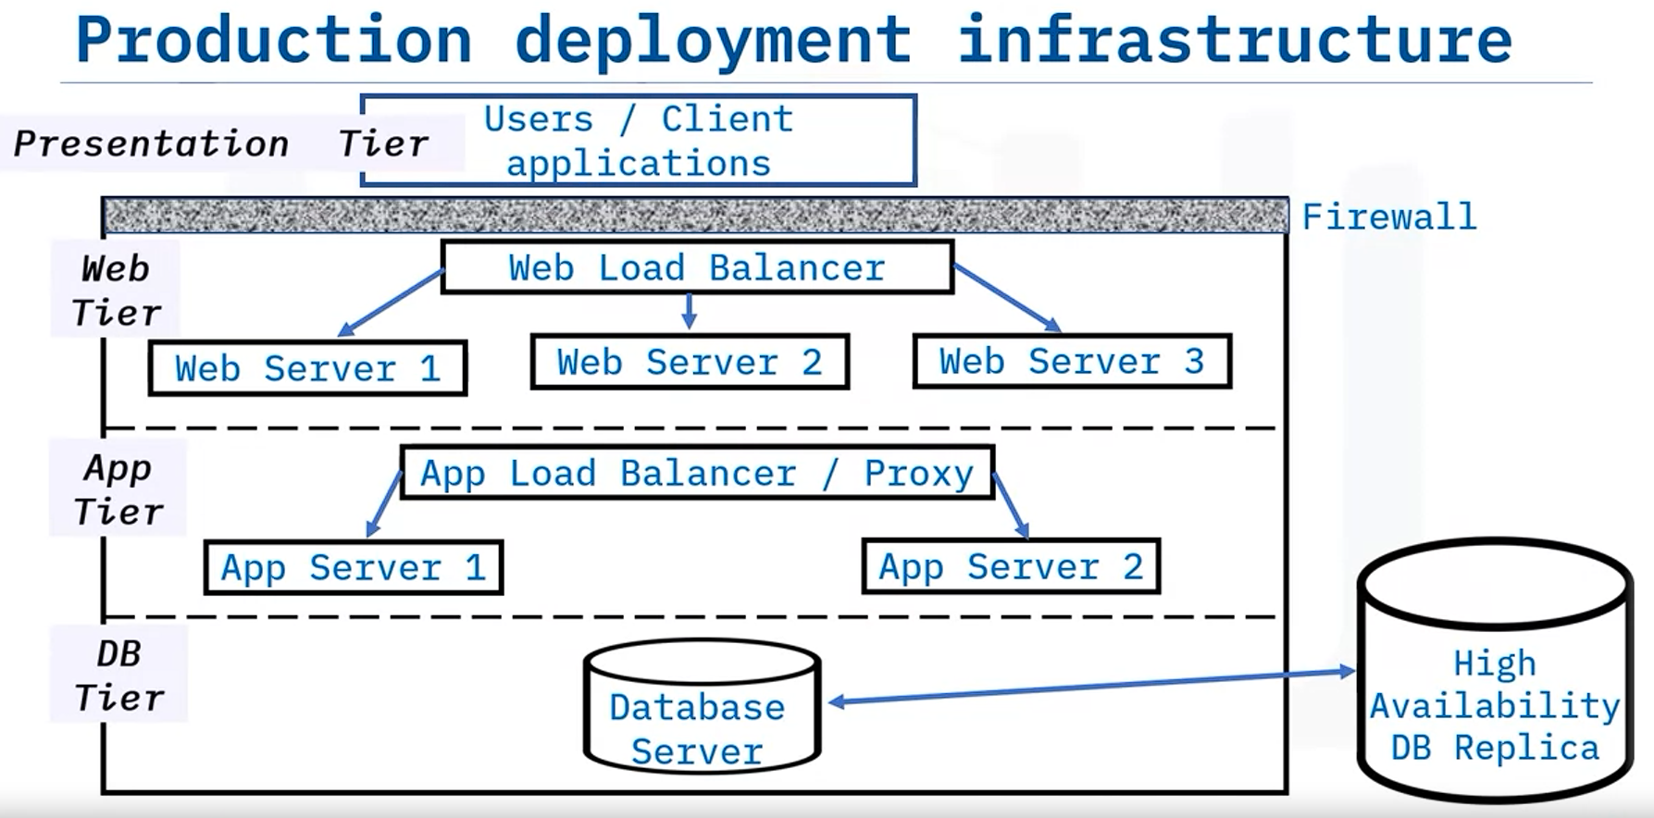
* Firewall:
  + Monitor traffic between an interior and exterior network.
  + Permit or block data based on a set of security rules.
  + Barrier between the networks and internal network to block viruses and hackers
* Load balancers:
  + 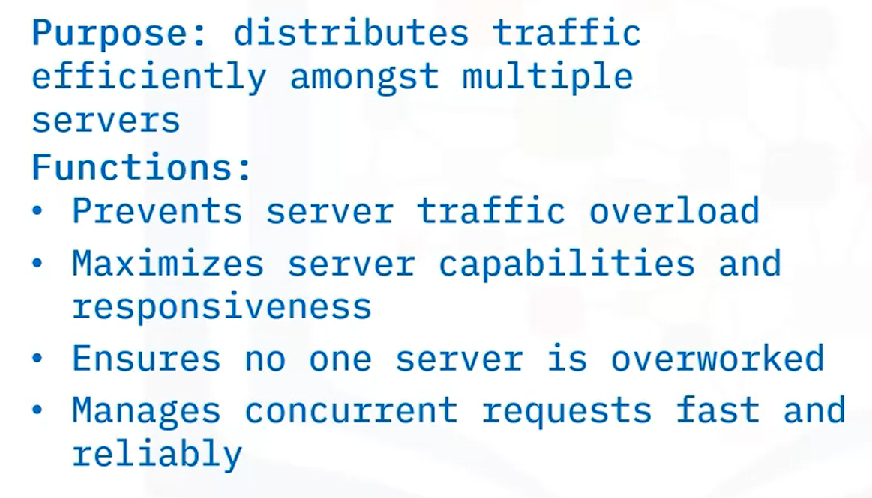
* Web and app servers:
  + 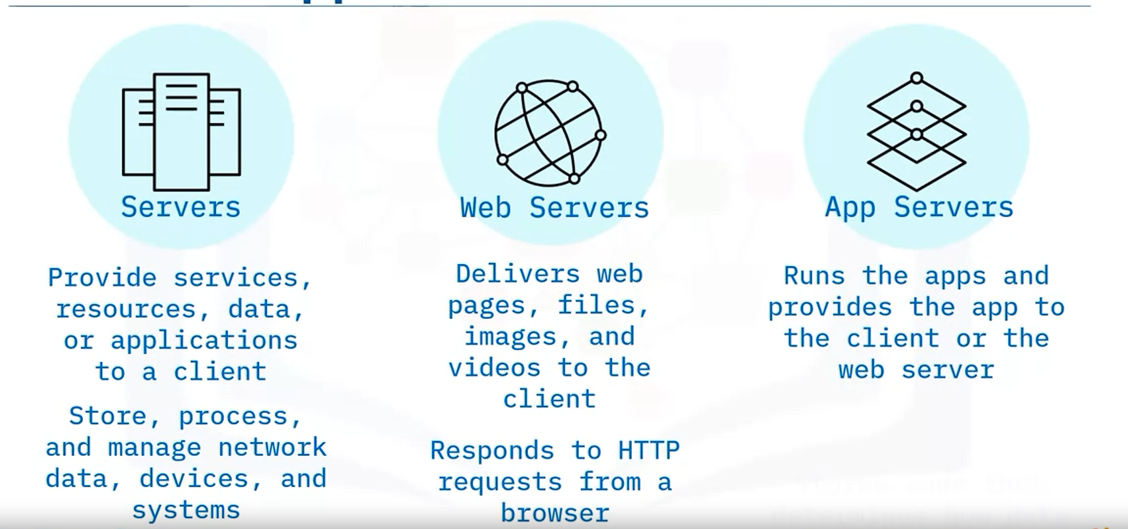
* Proxy server:
  + 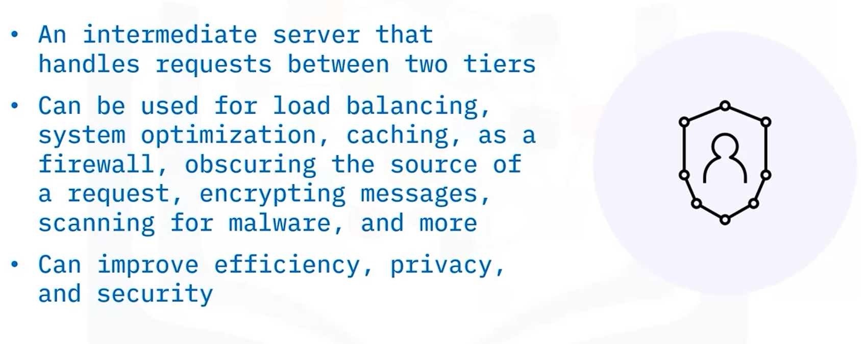
* Databases and database servers:
  + Are a collection of related data stored on a computer that can be accessed.
  + DBMS controls a database by connecting it to users or other programs.
  + Database servers control the flow and storage of data.

## **Software engineering teams**

* off-the -shelf software (pm có sẵn)
* Bespoke software (pm thiết kế riêng)
* Internal software (pm nội bộ)
* Data integration
* Business logic
* User interfaces

## **Software engineering tasks**

